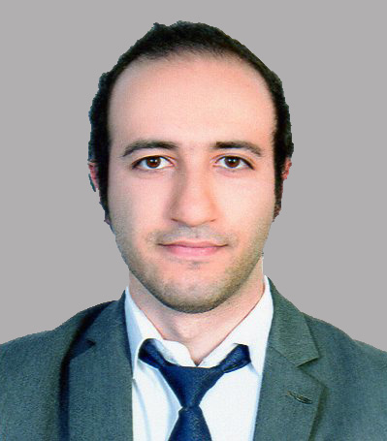

Ebrahim Sabri Mohammed
ebrahim.murad96@gmail.com, Mobile: (+973)66336554,
Road 1437, house 2966, block714

Profile:
To work towards achieving the greater success in my career through hard work, consistency and the ability to work with others to achieve organizational goals, aims and objectives.

Education Qualification:
- 2018-2019 Diploma in Hospitality Management
- 2011-2013 Isa Town Secondary School Certificates, Business
Experience:
- Trained in Capital Club
- Worked 3 Months in kitchen at Windham grand hotel
- 3 months training in Culinary
Skills:

- Strong oral written communication in Arabic and English
- Certificate of attendance in Capital Club
- Fluent in Computer
- Careful to follow direction.
- Detail oriented.
- Ability and flexibility to adept with team work.
- Ability to work under pressure.

Interest and activities:
- Swimming
- Cooking
- Football
- Basketball
- Traveling
- Movies

Personal Information:
- Nationality: BAHRAINI
- Date of Birth:16 March, 1995
- Marital Status: Single

References:
References available upon request

